Circuit Analysis (Lab1) Experiment 1: Introduction to Lab Instruments and Components

Name: Muhammad Zia Ur Rehman Zahid Registration No: 2025-CE-104
Date: 16-March-2026 Grade and Signature: ………………………
CLO2 | Use with identification the circuit components, breadboards, multimeters, power supplies, signal generators, and oscilloscopes.
Psychomotor/Affective | Level1 (1) | Level2 (2-3) | Level3 (4-5) | Level4 (6-7)
Report Marks (3) |  |  | Total marks (10)

_
Objectives: This experiment will provide exposure to the various test equipment to be used in subsequent experiments. A primary purpose of this lab course is for you to master the use of electronic test equipment.

Equipment required:
Power Supply, Breadboard, Oscilloscope, Signal Generator Connecting wires, Resistances, Multimeter.

Procedure

BREADBOARD-BASICS:
Breadboards (aka. Solderless board, Prototype board) are simply a set of pre-wired interconnected strips that are accessible through periodically spaced hole in the board. Looking at Figure 1. You can identify which holes form an interconnected strip by the black lines connecting them. By plugging the lead of a component into a hole you will be connected to all the other components in that strip without permanently connecting them. This allows you to build, alter, and test your prototype circuits quickly. There are two basic types of strips. The first type is called connection strip, they typically take up most of the board and are connected horizontally. Each hole can be uniquely identified using the labels “a-j’ column labels and ‘1- 63’ row labels.

NOTE: ‘a-e’ connection strips are not connected to the ‘f-i’ connection strips. The second type is called bus strip. ALL the holes in a bus strip are connected vertically. Bus strips are typically labeled ‘A’ or ‘B’ and are marked by a red or blue line along their length.

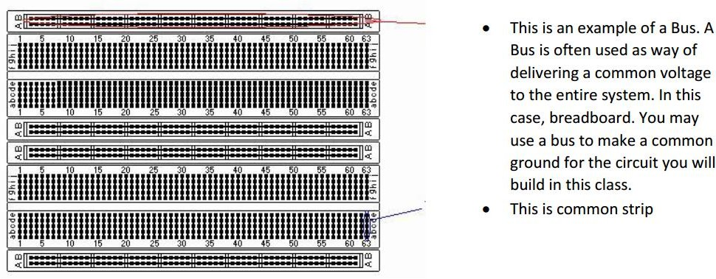

Figure 1 Breadboard

Recognition of Basic Components
Here we are going to get acquainted to some of the basic components used in circuits such as the resistors.
We will learn how to read the values using the codes as well as how to measure them using the ohmmeter.
Resistors
You will be given some resistors, use the instruments to find their values and fill out the Table 1-1.

Table 1 Comparison between nominal and measured values.

Measured
Resistor 1
Resistor 2
Resistor 3

Recognition of Basic Equipment
Before proceeding with the lab, please familiarize yourself with setting up the bench equipment. Refer to
Section 3 for details.
OSCILLOSCOPE
Figure shows the digital storage oscilloscope.
Features
Intensity Control

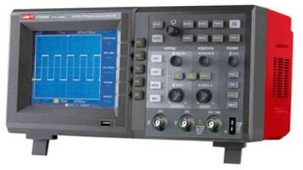
Figure 2 Oscilloscope

Rotate clockwise to increase the display intensity; counterclockwise to decrease. You can vary the intensity control to bring out signal detail, much like an analog oscilloscope. Digital channel waveform intensity is not adjustable.

Auto-scale Key
When you press the Auto scale key the oscilloscope will quickly determine which channels have activity, and it will turn these channels on and scale them to display the input signals.

Vertical Position Control
Use this knob to change the channel’s vertical position on the display. There is one Vertical Position control for each channel.
Channel On/Off Key
Use this key to switch the channel on or off, or to access the channel’s menu in the soft-keys. There is one Channel On/Off key for each channel.
Vertical Sensitivity
Use this knob to change the vertical sensitivity (gain) of the channel.
Auto-Probe Interface
When you connect a probe to the oscilloscope, the Auto Probe Interface attempts to determine the type of probe and set its parameters in the Probe menu accordingly.
Horizontal Delay Control
When the oscilloscope is running, this control lets you set the acquisition window relative to the trigger point. When the oscilloscope is stopped, you can turn this knob to pan through the data horizontally. This lets you see the captured waveform before the trigger (turn the knob clockwise) or after the trigger (turn the knob counterclockwise).
Horizontal Sweep Speed Control
Turn this knob to adjust the sweep speed. This will change the time per horizontal division on the display. When adjusted after the waveform has been acquired and the oscilloscope is stopped, this has the effect of stretching out or squeezing the waveform horizontally.
Measure Keys
Press the Cursors key to switch on cursors that you can use for making measurements. Press the Quick Measure key to access a set of predefined measurements
Measurements using Oscilloscope
The oscilloscope is primarily a voltage-measuring device. Once you have measured the voltage, other quantities are just a calculation away. For example, Ohm's law states that voltage between two points in a circuit equals the current times the resistance. From any two of these quantities, you can calculate the third. Another handy formula is the power law: the power of a DC signal equals the voltage times the current. Calculations are more complicated for AC signals, but the point here is that measuring the voltage is the first step towards calculating other quantities.
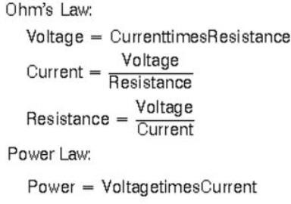
Following figure shows the voltage of one peak - V[p] - and the peak-to-peak voltage - V [p-p] -, which is usually twice V[p]. Use the RMS (root-mean-square) voltage – V [RMS] - to calculate the power of an AC signal.

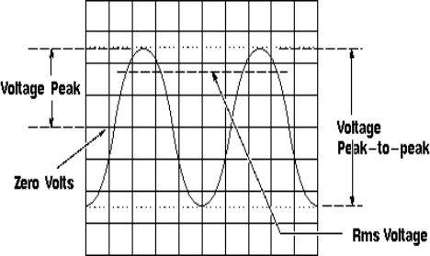

Figure 3 Voltage Peak and Peak-to-peak Voltage
Steps to Measure Voltage
- Each probe has an alligator clip for connecting the scope to ground. Connect one of these clips to your circuit's ground. It's not necessary to connect the clip on the other probe.
- Connect a probe to a point in your circuit that has a voltage you want to measure.
- If there's another voltage you'd like to measure, connect the other probe to this second point.
- Each square on the screen's grid is one centimeter. Above, you set the VOLT/DIV knobs to 1V. This means that each centimeter represents 1 volt, and each smaller division represents 0.2 volts.
- If the voltage you're measuring is greater than 8 volts, the trace will go off the screen. If this happens, set the VOLT/DIV knob to a larger voltage.
- An alternative to having the zero points for both traces on the bottom line of the grid, is to have one zero point on the center grid line, and the other on the bottom line. If the voltages you're working with go negative as well as positive, you'll probably want to have one zero point on the line 2 centimeters down from the top and the other on the line 2 centimeters up from the bottom.
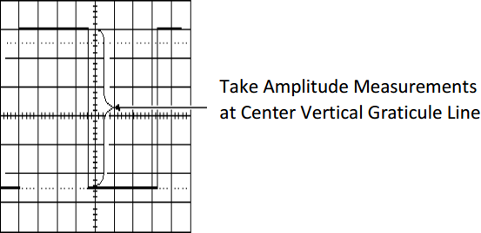
Figure 4 Measure Voltage on the Center Vertical Graticule Line
Frequency Measurement
Frequency can be measured on an oscilloscope by investigating the frequency spectrum of a signal on the screen and making a small calculation. Frequency is defined as the several times a cycle of an observed wave takes up in a second. The maximum frequency of a scope can measure may vary but it always in the 100’s of MHz range. To check the performance of response of signals in a circuit, scope measures the rise and fall time of the wave.

Method to Measure Frequency
  - Increase the vertical sensitivity to get the clear picture of the wave on the screen without chopping any of its amplitude off.
  - Now adjust the sweep rate in such a way that screen displays a more than one but less than two complete cycles of the wave.
  - Now count the horizontal number of divisions of one complete cycle on the graticule from start to end.
  - Now take horizontal sweep rate and multiply it with the number of units that you counted for a cycle. It will give you the period of the wave. The period is the number of seconds each repeating waveform takes. With the help of period, you can simply calculate the frequency in cycles per second (Hertz).
Method to Measure Current
Attach a probe with the resister to an electrical circuit. Make sure that resistor’s power rating should be equal or greater than the power output of the system.
Now take the value of resistance and plug into Ohm’s Law to calculate the current. According to Ohm’s Law,
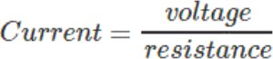

Signal Generator
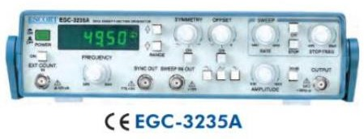
The signal generator is used to generate signals for your circuits. You will need to know how to set the signal generator to get sine, square, triangle or ramp signals. In addition, you will have to set up the frequency, the amplitude, offset voltage and the duty cycle. The default settings for this instrument are a sinewave of 1 kHz, with an amplitude of 100 mV and a DC offset of 0.0 V. The signal generator is very easy
to use since each function has a specific button. If you want to select a waveform, just look

for the button with the desired waveform such as a sine wave, a square wave, triangle wave, or
Figure 5 Signal Generator

ramp wave. Then, just press its button. All that you have to do now is set the parameters for the waveform. To set the frequency, amplitude, offset or the duty cycle you need to do the following:

- Press the appropriate gray buttons beneath the display screen (Freq/Period, Ampl/Hi Level, Offset/Lo Level, or Duty Cycle).
- You may enter the value one of two ways.
  - Turn the knob and the highlighted digit will change. You may select a different digit by using the < or the > buttons.
  - You can also key in the digit by using number buttons.
- Press “Output” button on the bottom right of the front panel (right next to Sync cable) and make sure the light is “on”.

Post Lab Questions
- Define Oscilloscope and write its applications.
An oscilloscope is an electronic instrument used to display and analyze electrical signals (voltage) in the form of waveforms.

Applications
- To observe signal waveforms
- To measure voltage
- To measure frequency and time period
- To analyze electronic circuits
- To detect faults in electronic signals

- What is Peak to Peak Voltages?
Peak-to-Peak voltage (Vpp) is the difference between the maximum positive peak and the maximum negative peak of a waveform.
Vpp=Vmax−Vmin
For a sine wave:
Vpp=2Vp​
- What is RMS value?
RMS (Root Mean Square) value is the effective value of an AC voltage or current that produces the same power as a DC voltage.
For a sine wave:
Vrms=Vp/(√2)

- Write the RMS values of Sine, Square and Triangular wave?
Sine Wave
Vrms = Vp/(√2) ≈ 0.707V
Square Wave
Vrms = Vp
Triangular Wave
Vrms = Vp/(√3) ≈ 0.577V

- Explain DC offset?

DC offset is the amount by which an AC signal is shifted above or below the zero voltage level.
If a waveform is centered at 0V, there is no DC offset.
If the waveform is shifted upward or downward, then DC offset is present.
Example:
If a sine wave oscillates around +2V instead of 0V, then DC offset = 2V.

